

ForceWinder Kawasaki VN 2000 Installation Instructions; Please read these instructions BEFORE installing your new ForceWinder. *Use Blue Loctite on all mounting hardware bolts.
ATTENTION! A factory service manual may be helpful in performing this installation. Do not attempt to perform this installation if you are not confident in your ability to complete all of the steps in the procedure; consult a trained technician.

Stock Air Cleaner Removal Instructions:
- Remove the seat and rear-mounting bolt on the fuel tank.
- Prop up the rear of the tank; a small block of wood works well.
- **Steps 1 & 2 May not be needed. Check n see if removal of air cleaner is easy first.
- Remove your stock air cleaner and spark plug covers.
- Keep 4 of the oem stock bolts to re-use on the adapter plate that mounts onto the throttle body.
- Remove the two hoses that are connected to the back of the air box as well as removing the temp sensor.
- The one hose will connect to the TOP of the adapter and the other to the LOWER side. The temp sensor will come apart and snap into the lower large diameter hole on the adapter. Please note that there maybe two sizes of the poly elbows needed so we are supplying extras.
- After the adapter is in place use the smaller gasket supplied and insert the ForceWInder Elbow, once all four ¼ x 20’s are on snug up then tighten.
- Slip ForceWinder Filter over the Elbow and add the clamp to keep it secure.
- Slip on Pre Filter Sock and be sure to ride with this sock on the keep your filter clean, remove the filter sock and wash with a liq soap then let dry.
- Possible re-tune may be needed for optimum performance.

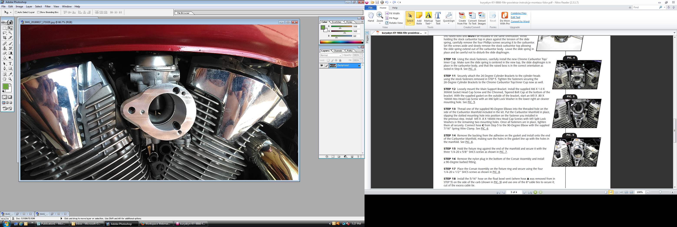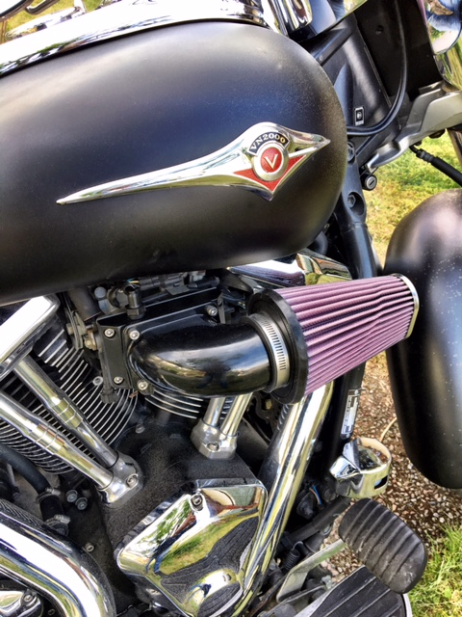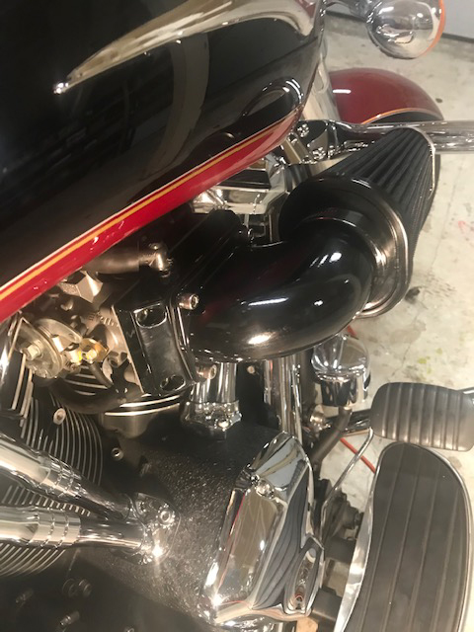

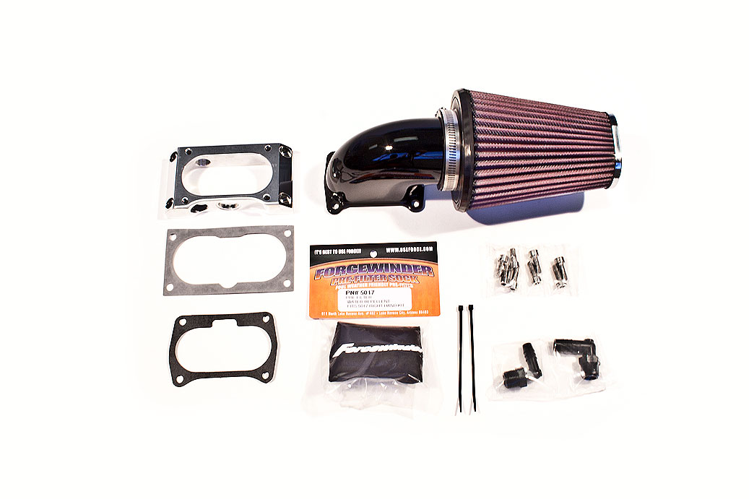

ForceWinder ~ A 3 Lizards Performance Company
Fountain Hills, Arizona :: 928-846-1677 :: www.UseForce.com

TEXT US A FEW PICTURES @ 928-846-1677

